1.Git Status to check the changes that need to be committed or staged.

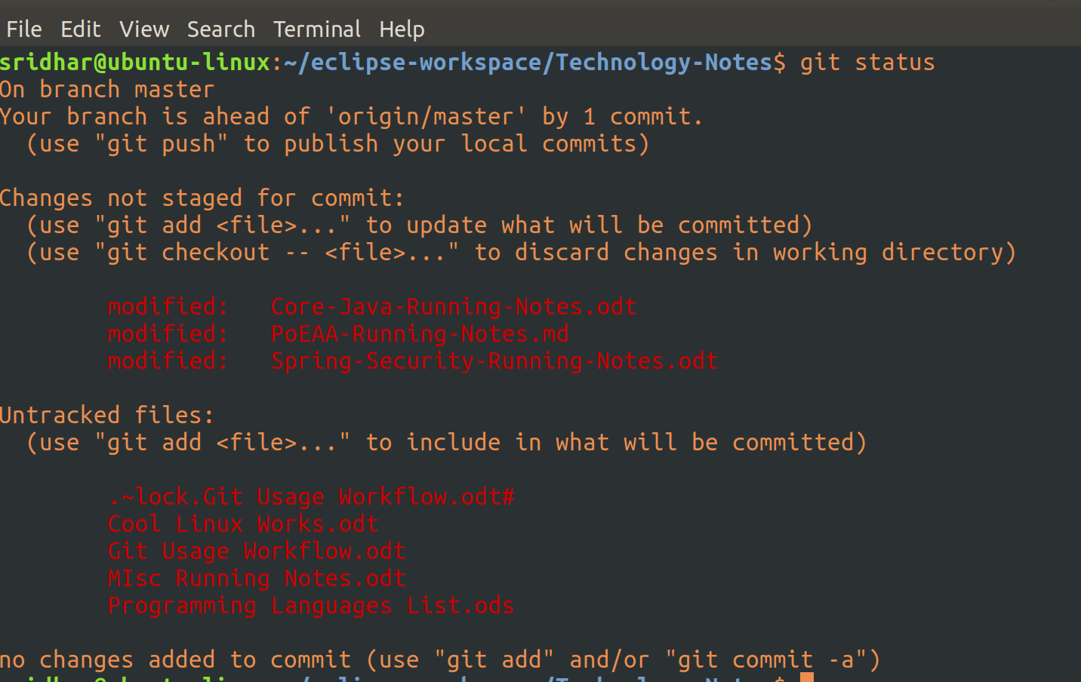
This basically shows you the high-level differences b/w your local repo and the remote repo.

As you can see above, this is the normal linux command terminal. First, navigate to the directory for which you want to see that status in comparision with it’s remote repo, which, in this case is ‘Technology-Notes’.

As you can see, it says, 3 files are modified and there are 4 new files which are not on the remote repo.

2.Staging, Committing and Pushing a file

Now, if you want to push your local modifications into the remote repo, you first have to stage the file(s). And ‘git add <file-name>’ is the command to do that.

When you do a git add command, it basically stages the said file(s), meaning, it will create an index file in which an entry of these file(s) will be made.

Git’s add command is used to stage both modified and new changes.

So, I have just staged a single file (Core-Java-Running-Notes.odt) which basically was modified locally.

Now, if you run a ‘git status’ command:

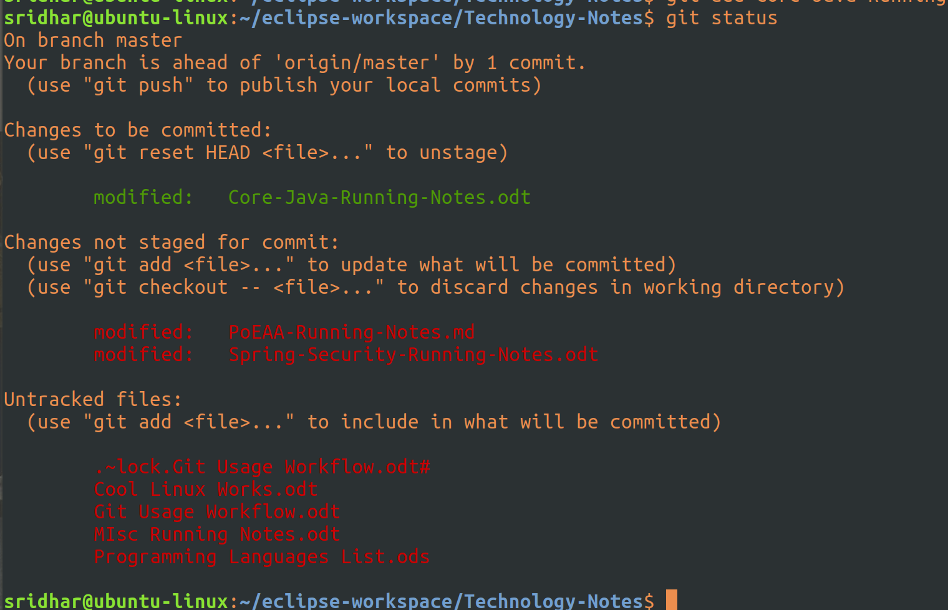
So, this says, one file (Anki Questions.odt) is staged and yet to be committed and 3 files are modified and yet to be staged and there are 3 new files which are not on the remote repo.

It shows us that 1 file is to be committed, 2 files are not yet stages (and are modified locally), and 4 files are untracked (not present in remote repo).

Now, let’s go ahead and commit the staged file. To commit a staged file, you need to run: git commit -m “some message”

When you run the above the staged file is not committed to remote repo but is only saves a new commit object in the local git repo. This is unlike other versioning systems (like svn), where by commit, it pushes the changes to the remote repo.

So, when you do a commit in git, it saves a new commit object in the local git repo which then has to be pushed, fetched or pull to the remote repo.

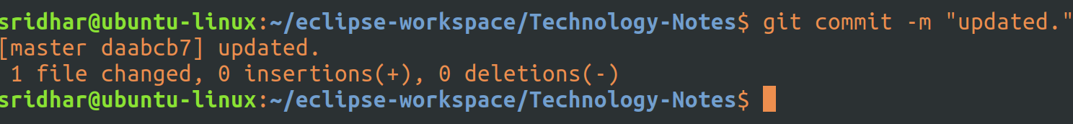
As you can see from above, it says, 1 file changed. Now the file that was staged earlier ( Core-Java-Running-Notes.odt) has been now locally committed as a new object in the local repo, ready to be pushed to the remote repo.
Now, let’s again run git status to see what it says:

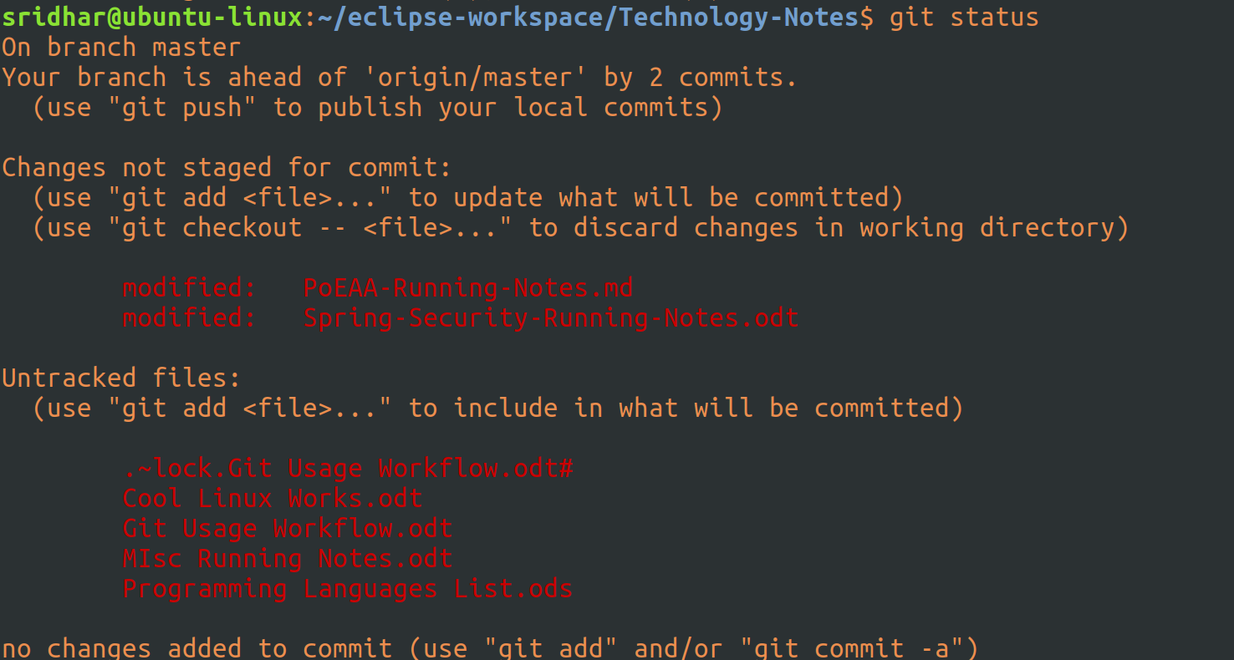
It says, ‘your branch is ahead of master by 2 commits’ - 2 because, one i have already done and the second one is the one which we have done above. So, basically, there are now 2 commites which are to be pushsed into remote repo or also called as master or origin.

Push the files to master:
To push the commits to the remote repo/master, run the command:
git push origin master

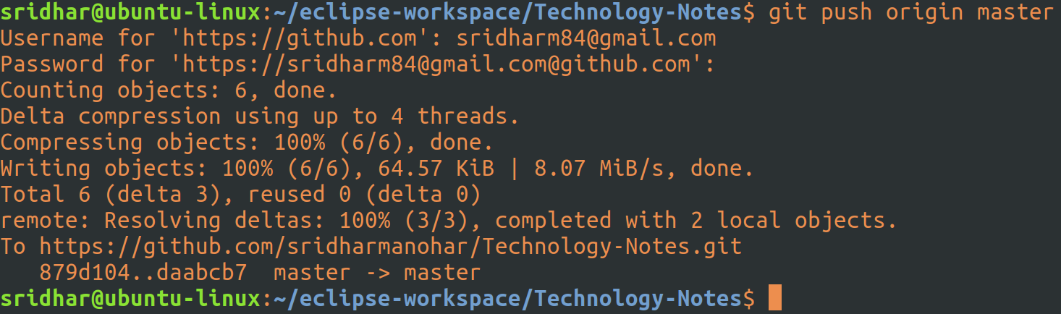

Asks for username and password of the git repo you are trying to push to and then pushes the changes.

Now, run the git status command to check the status:

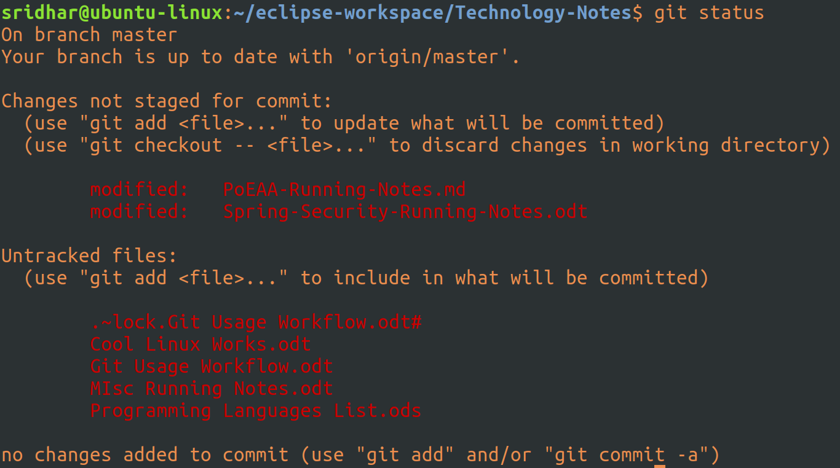
So, as expected, it says, branch is up to date with ‘origin/master’.

3.Mass Staging

We can also do mass staging by running the following command: git add .

This will basically stage all modifications/new files that are to be staged.

